1st usability question

How do I add a user as a friend?

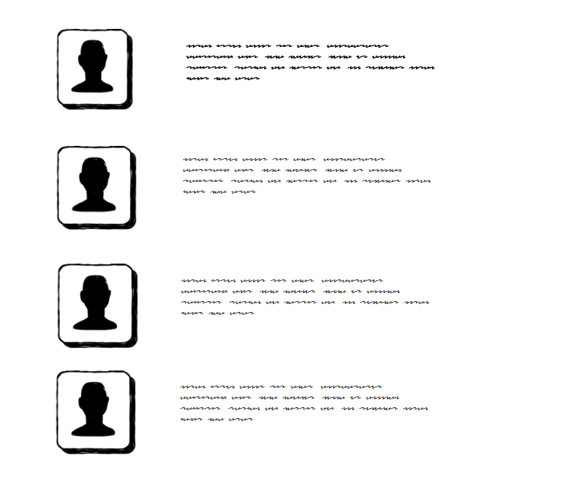

The image is showing the users who commented. Let’s say I wanted to befriend the 1st user. Clicking on the profile picture will show the options below.

Profile

Add as friend

Forum History

Mute

Report

Clicking on the “add as friend” option will then show the user you want to befriend the interface below.

Friend Request

Reject

Accept

2nd usability question

How to report users for inappropriate comments/questions/language



This is the same image as the 1st usability questions. Let’s say that we are moderating the forum. Clicking on a profile picture will display the interface below:

Profile

Add as friend

Forum History

Mute

Report

Clicking on the “Forum History” option will then show the user’s track record of all his threads, comments and activities.

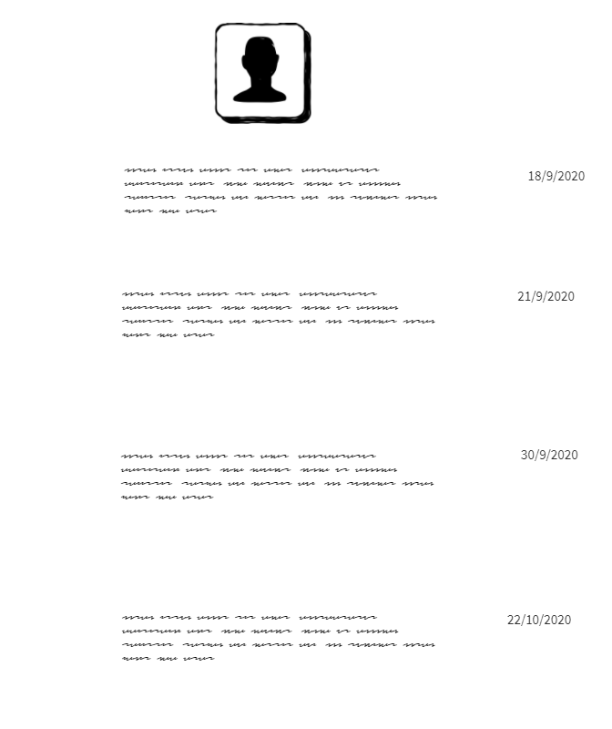

This would be what we will see when we see the user’s history in the forum. Here we would check for any inappropriate comments/questions/language now and in the past. If any such language is discovered, return back to the profile interface and press the “Report” button.

Profile

Add as friend

Forum History

Mute

Report

Below will the options that we the users can report a user for.

Inappropriate language

Harassment

Stalking

Plagiarism